Jose Corona

Home Task2

FANUC R-2000iC/165F

Description of the robot.

Robot with 6 joints and 7 links. Had and spherical wrist.

Kinematic scheme with description of the parameters.

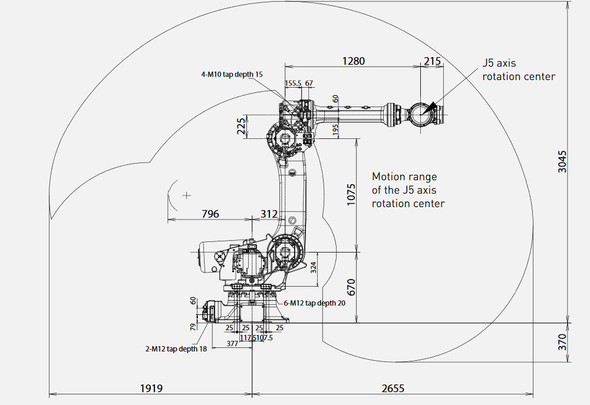

DOF: 6

d1=346

d2=324

d3=312

d4=1075

d5=225

d6=1280

d7=215

Formulas of forward kinematics solution.

T=T_z(d1)*R_z(q1)*T_z(d2)*T_x(d3)*R_y(q2)*T_x(d4)*R_y(q3)*T_z(d5)*

T_x(d6)*R_x(q4)*R_y(q5)*R_z(q6)*T_x(d7)

Step by step explanation of inverse kinematics solution.

For the numerical implementation, we use the Jacobian, evaluated in the previous instant time, for the joint variables.

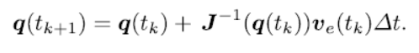

To overcome the problem of the end-effector pose is different than the corresponding, we could use an operational space error formula.





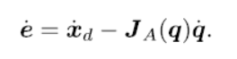

Link to the project on github.